Project Design Phase-II

**Technology Stack (Architecture & Stack)**

|  |  |
| --- | --- |
| Date | 14 October 2022 |
| Team ID | PNT2022TMID30503 |
| Project Name | Classification of Arrhythmia by Using Deep Learning with 2-D ECG Spectral Image Representation |

# Technical Architecture:

The Deliverable shall include the architectural diagram as below and the information as per the table1 & table 2

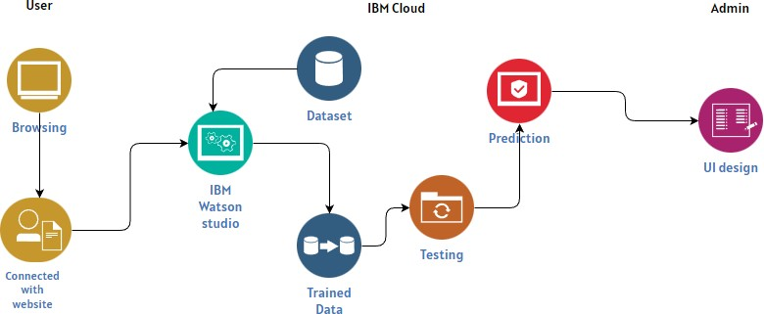

# Table-1 : Components & Technologies:

|  |  |  |  |
| --- | --- | --- | --- |
| **S.No** | **Component** | **Description** | **Technology** |
| 1. | User Interface | Web UI, Mobile UI. | HTML, CSS, JavaScript / React Js. |
| 2. | Application Logic-1 | Python is used for backend | Python |
| 3. | Application Logic-2 | It's a symbolic math toolkit that performs a variety of tasks including deep neural network training and inference using dataflow and differentiable programming | Tensorflow |
| 4. | Cloud Database | A global technology company that  provides hardware, software, cloud-based services and cognitive computing. | IBM Cloud |
| 5. | File Storage | Breaks up data into blocks and then stores  those blocks as separate pieces, each with a unique identifier. | IBM Block |
| 6. | External API-1 | Purpose of External API used in the  application | IBM Weather API, etc. |
| 7. | External API-2 | Purpose of External API used in the application | Aadhar API, etc. |
| 8. | Machine Learning Model | Object recognition is a subfield of computer vision, artificial intelligence, and machine  learning | Object Recognition Model |
| 9. | Deep learning Model | The images from the created dataset are fed into a neural network algorithm. | Image Recognition Model |

Table-2: Application Characteristics:

|  |  |  |  |
| --- | --- | --- | --- |
| **S.No** | **Characteristics** | **Description** | **Technology** |
| 1. | Open-Source Frameworks | Building user interfaces based on UI components. | React Js |
| 2. | Security Implementations | OWASP is a nonprofit foundation that  works to improve the security of software. | OWASP |
| 3. | Scalable Architecture | a modular client-server architecture that consists of a presentation tier, an application tier and a data tier | 3-tier architecture |
| 4. | Availability | The data on each server can be  simultaneously accessed and modified via a network. | Distributed Server |
| 5. | Performance | Increasing data retrieval performance by reducing the need to access the underlying  slower storage layer. | Cache |